CPSC 4317: Computer Networks
Homework 1
Due 10:00 am, Feb. 3, 2023 (Friday)

Name: Kevin Nguyen

LUID: L20434463

Date: 1/30/2023

The following questions are 10 points each:

Textbook: P. 15 -> Question 1.11: List the layers in the TCP/IP Model and give a brief explanation of each.
- Physical
  - Underlying transmission mediums and hardware. Anything that has electrical properties, radio frequencies, and signals.
- Network Interface
  - Protocols here communicate over a single network and acts as an interface to layer three.
- Internet
  - Protocols here are the solid foundation for the internet. Here we have communication between two computers across multiple interconnected networks.
- Transport
  - Protocols here lets an application on one computer communicate with another computer. There are mechanics to avoid network congestion and to set the max rate a receiver can accept data.
- Application
  - Protocols here format and define the meaning of messages that applications communicate to each other.

Textbook: P. 80 ->
Question 4.9: What data objects does a browser cache, and why is caching used?
Most of the data objects are GIFs and JPEGs, because they are often used as backgrounds and banners. If we save them in a cache and use the cached copy whenever we go back to the site, it would load faster, because we already had a majority of the website downloaded.

Question 4.12: When a user requests an FTP directory listing, how many TCP connections are formed? Explain.
There are 11 connections.
- Client forms control connection
- Clients sends directory request over the control connection
- Server forms data connection
- Server sends directory listing over data connection
- Server closes data connection
- Client sends download request over control connection
- Server forms another data connection
- Server sends a copy of the file
- Server closes connection
- Client sends QUIT command
- Client closes control connection

Question 4.16: List the three types of protocols used with email and describe each.
- Simple Mail Transfer Protocol (SMTP)
  - Uses stream paradigm and only transfers text messages. Lets the user transfer messages to an email server from a local machine.
- Post Office Protocol Version 3 (POP3)
  - Removes messages once they are downloaded.
- Internet Mail Access Protocol (IMAP)
  - Can send to multiple devices at the same time.

Question 4.22: What is the overall purpose of the Domain Name System?
DNS allows us to give certain names to computer addresses.
Programming Question (50 points):

Please read chapter 3 to have a basic understanding about socket programming.

After this, please download “example socket program” (socket_program.tar.gz) in the BlackBoard website. Please upload socket_program.tar.gz to a linux machine, then run:
- gunzip socket_program.tar.gz
- tar xvf socket_program.tar

you will obtain the list of socket programs. Please refer to video “Socket Demo” to see how to use these socket programs.

In these socket programs, there are client.c and server.c. Please compile and run these two programs and make them work. Please

- Explain the basic functionality of server.c and client.c
- Run server and client.
- Turn in a screenshot to show how you run them.

- On the server side, after we run the program, we wait for the connection from the client. Then, we send a message to them that says how many times they have connected so far. Finally, we close the connection and wait for the next time we connect. We first have to compile the file by doing gcc server.c -o server.
On the client side, It tries to figure out what is the IP address and port number on the server side. Then, the client tries to actively connect to a server. After connecting with a server, we receive the message and print it out. Finally, we close the port. We first have to compile the file by doing gcc client.c -o client.
- 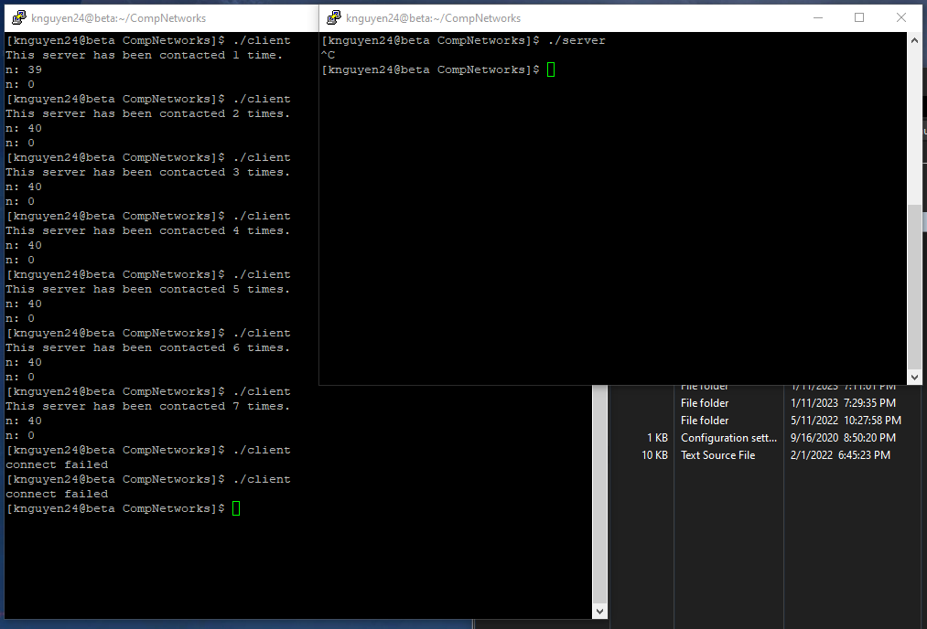
How to Turn In:

Only softcopy is required.
- Please use the blackboard system to turn in the softcopy of all your solutions.
- For programming questions, please do NOT use MS WORD. Please send .c files.

